Name ___________________________________ Block ____________ Date _____________
Introduction to Measuring and Significant figures
In experiments scientists from all fields use the international system of units (Si). It is the standard metric system most commonly used by engineers and scientist from all fields. By using the same measurement system all over the world for experiments, there is little room for mistaken values. In measuring numbers can be reported as measured numbers and exact numbers. Accuracy, precision and significant figures help in chemistry, because chemistry is an observational science that involves experimentation. Experiments yield data obtained using various measuring devices, and how good your calculations can make or break and experiment.
Objectives:
Identify metric units such as grams, meter and liter.
Report a measurement with the correct number of significant figures and units.
Perform calculations and write the answers with the correct number of significant figures and units

Measurement | SI Unit | Metric Unit
Mass | Kilogram (kg) | Gram (g)
Volume | Cubic meter (m³) | Liter (l)
temperature | Kelvin(k) | Degrees Celsius (C ⁰)
Length | Meter (m) | Meter (m)
energy | Joules (j) | Calorie (cal)

The table above shows some examples of the most common metric and SI units used in lab measurements.
The table below shows common metric prefixes.

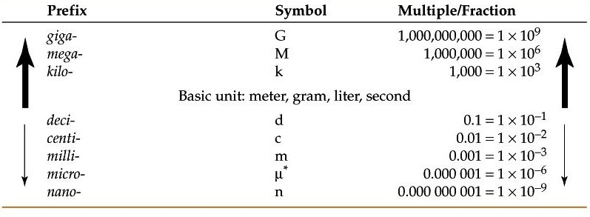
The table above shows some of the most common prefixes in the metric system. In every measurement there must include a value and a unit. For every measurement prefixes are attached in from of the unit.
Experimental Procedure and Data
- Measuring Length: Make sure you use the correct significant figures in your answers.
1. First Exam your ruler. You will be using this to measure the length of objects. Notice that there is one side of inches and the other side is cm and mm.
2. Measure your lab paper and record the measurements in cm.
length= ____ _____________ x width _________________
3. Convert your measurements from centimeters to millimeters.
length= ____ _____________ x width _________________
4. After you have gotten your measurements, calculate the area of the paper in cm², then you
will need to convert the area into mm² .
Area = l x w = _______________ x _______________ = ____________________
Or _______________ x _______________ = ____________________
Make sure you use the correct significant figures in your answers.

Measuring Volume:
1. Get a 150 ml graduated Erlenmeyer flask and fill it with water to the 50-ml mark.
2. When measuring record the volume to the nearest ml, then convert your answer to liters. After you have gotten your answer use the water in the flask for the next step.
a. _______________ ml b. ______________ l
3. Take a 250 ml graduated beaker and fill it with the same water from procedure 1. Record in ml, convert to liters.
a. _______________ ml b. ______________ l
After you have measured the water correctly transfer it to a 100 ml graduated cylinder.
Make sure that you measure the water correctly and do not spill any.
4. Once you have measured and gotten your results in the 100 ml graduated cylinder, record the volume of the water to 0.1 ml and convert it to liters. (THIS IS YOUR ACCEPTED VALUES FOR THE EXPERIMENT)
a. _______________ ml b. ______________ l

5. Calculate the error in volume measurement of the Erlenmeyer flask and the beaker using the formula:
%error = measured value - accepted value X 100
accepted value

Formula for % error is in Table T in your reference table.
Show work for % error below! Remember sig figs!
- Erlenmeyer flask

- beaker

Measuring Mass:
1. Use the digital scale to measure the mass for the following objects and then convert:
 | Milligrams (mg) | Grams (g) | Kilograms (kg)
Penny
Test tube
Spatula
Stirring rod

How many significant figures are recorded in each? Penny _____test tube_____spatula______stirring rod_______

Measuring Temperature:

- Use your thermometer to measure the room temperature of your laboratory classroom.
Make sure to record your findings in temperature to the nearest 0.1®C.
- Boil 100 ml of water in a 250 ml beaker. Once the water is boiling hold the thermometer in the boiling water for 1 minute.
Make sure the tip of the thermometer is submerged in the boiling water completely without touching the bottom of the beaker.
Record the temperature of the boiling water to the nearest 0.1®C.
To measure freezing point you will need to prepare a250- ml beaker filled halfway with crushed ice.
Then add water to the top of the ice. After ice and water are mixed place the thermometer in the ice water for 1 minute. Again, make sure the thermometer is fully submerged and not touching the bottom of the beaker.
Record your findings to the nearest 0.1®C.
- After you have recorded all of your temperatures in degrees Celsius. Convert them to degrees Fahrenheit and Kelvin.
  - Kelvin conversion is on table A of the reference table
  - Fahrenheit conversion F⁰ = C⁰ x(9/5) + 32

 | celsius | kelvin | fahrenheit
Room temp
Boiling point H₂O
Freezing point H_{2O}

Post-Lab Questions! Show work.
- A golden retriever dog weighs 78 lbs. What does it weigh in kilograms? 1lb = 0.454 kg;

- Two students measure a laptop in order to calculate its volume.
They recorded the length as 32.1 cm, the width as 28.7 cm, and the height as 3.1 cm.
The volume they reported using their calculator was 2855.937 cm3. What volume should have been reported by the students? Why?

3. Why could the measured values obtained by other fellow students be different from yours?

4. How did you determine the last digit in a measurement? Give an example.

5. Did you use prefixes in your measurements? If yes, give an example.

6. What is the length of the object next to the ruler? ____________________________
